[www.turnitin.com](http://www.turnitin.com)

Once you create an account, this is the class id and the password for login to our class:

8700277

avid14

Newspaper Account

**Go to** [**www.startribune.com/signup**](http://www.startribune.com/signup)

1. Enter the last name and phone number associated with your Star Tribune Digital Subscription

***Please note:  It works best if you copy and paste the information below right into the fields on the form.***

**Last name:**   BLAINE HS

**Phone number:**   763-506-6505

**Click “See my options”**



1. **Accept the terms of sale and privacy policy.  Click “activate my digital access”**

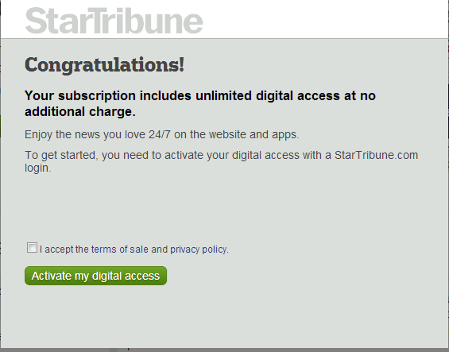

1. **Enter the email address and password individually for each user.  The Zip Code can be the zip code for your school address.  The year of birth and gender can also be generic for every user.  Accept the terms of use and click “Create Login”**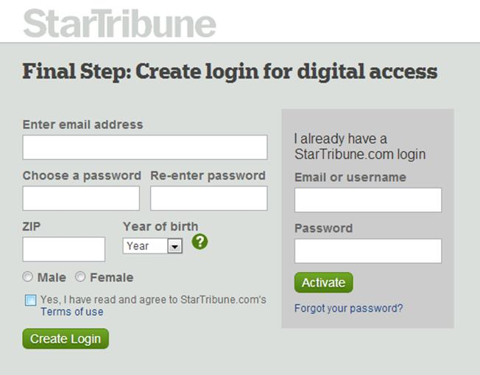

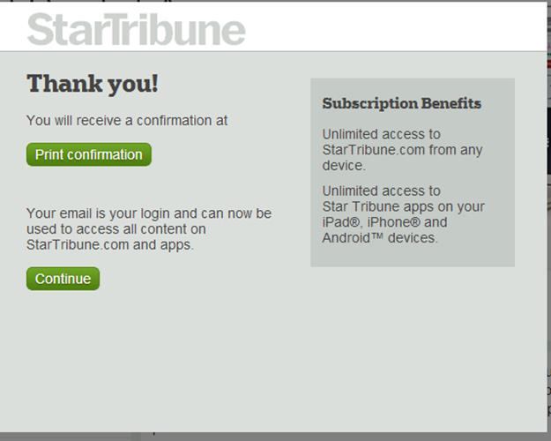

[www.naviance.com](http://www.naviance.com)

Miss. Nibbe will help us with that…